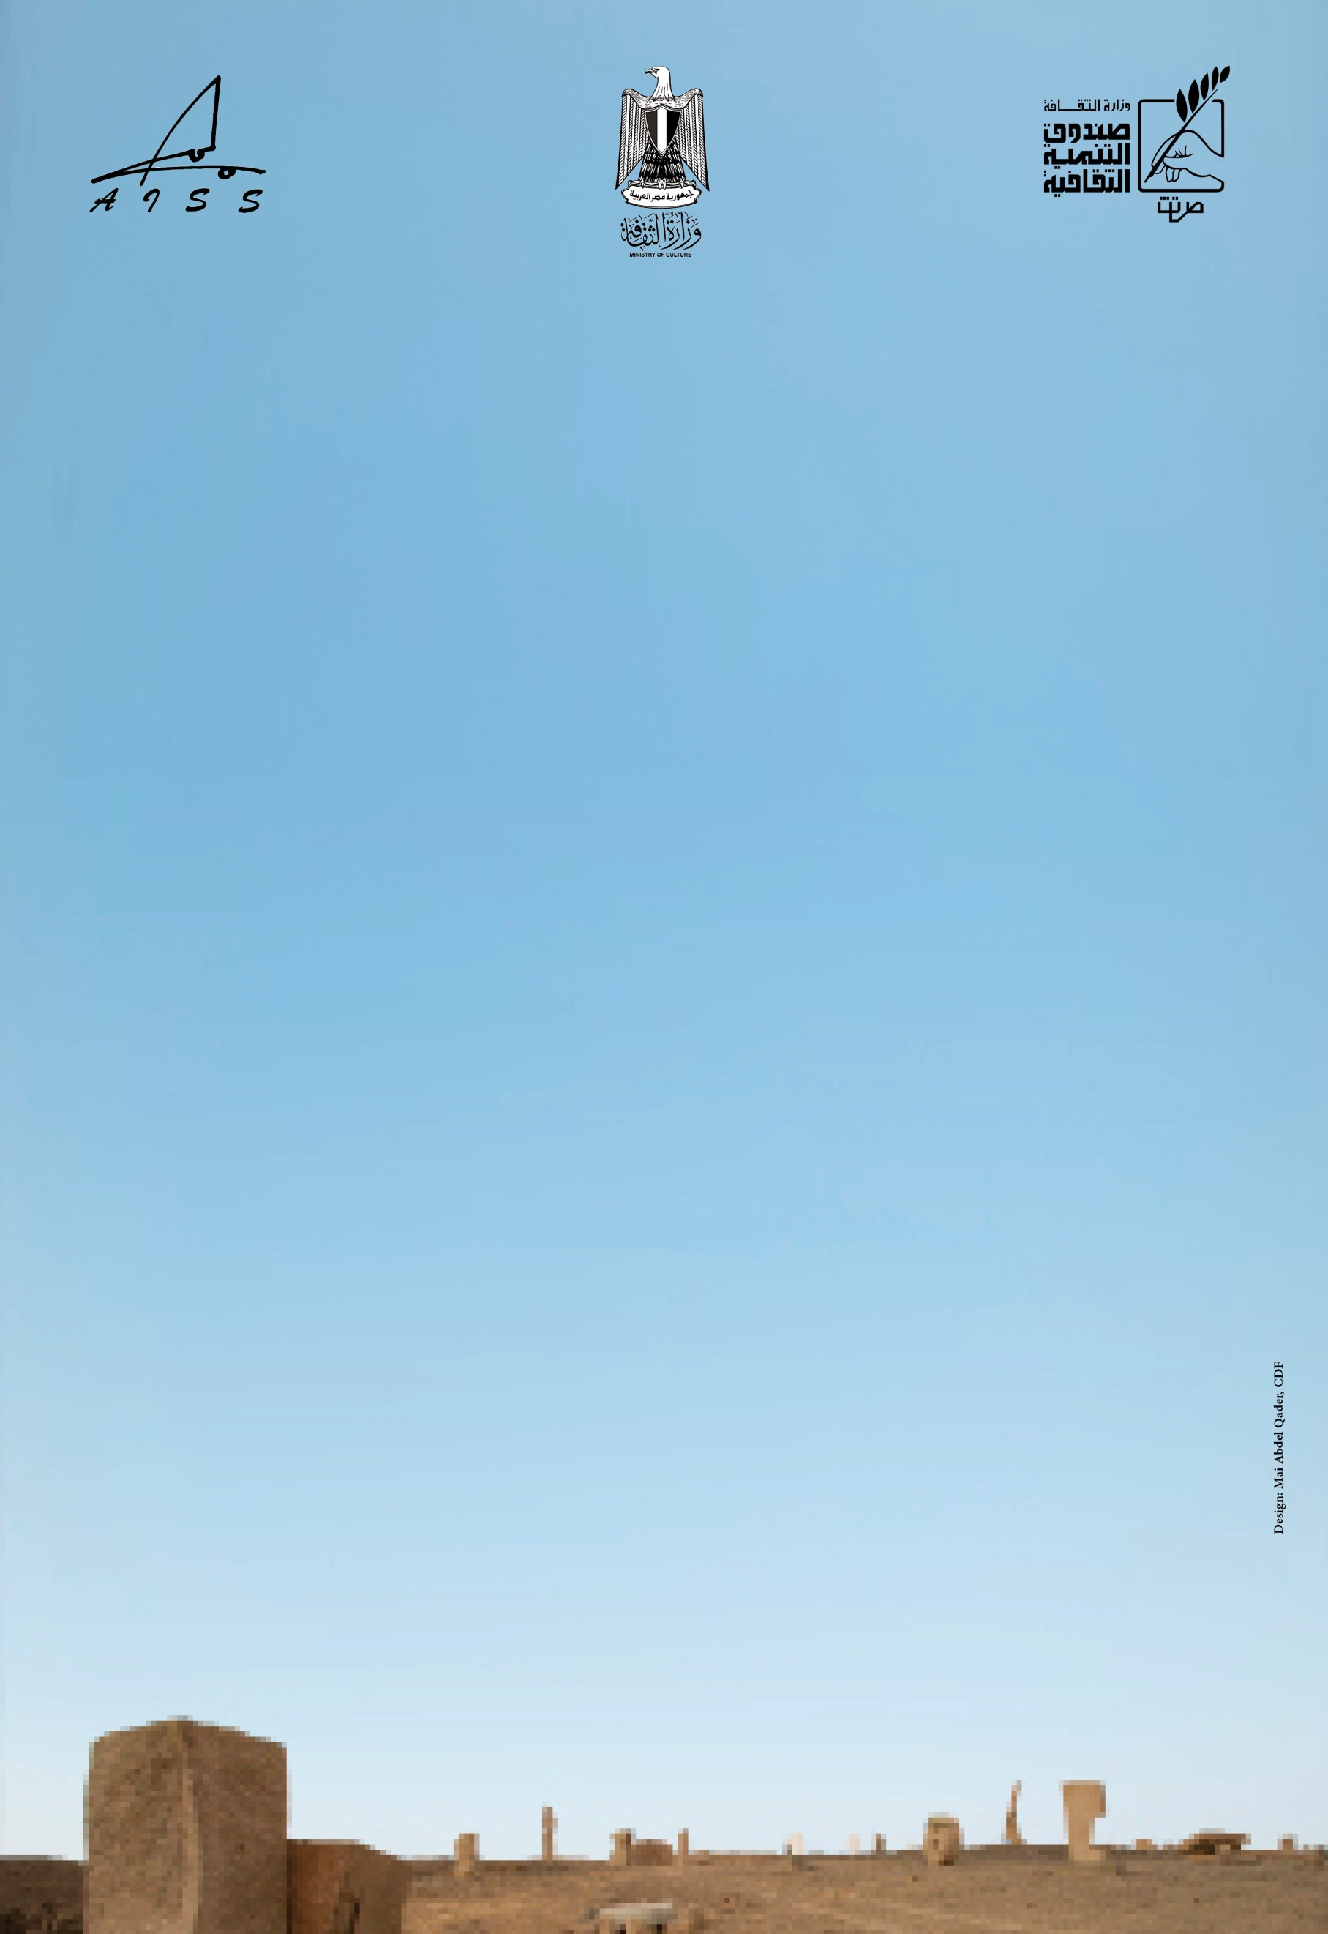

The 24th Aswan International Sculpture Symposium
Regulations

The Symposium was founded by the Ministry of Culture 1996, sponsored by the cultural Development Fund with the co-operation of Aswan governorate.
The main concern of the Symposium is to revive and continue sculpture on the Aswan Granite.
The 24th Aswan International Sculpture Symposium will take place from 19th January to the 9th March 2019.

The Cultural Development Fund provides the following:
- International flight ticket and domestic transportation (All travel tickets are reserved and paid by the Culture Development Fund).
- Full board accommodation in 4 stars Hotel -single room- (breakfast-lunch-dinner) and 2 pieces Laundry. Any additional personal expenses will be covered by the artist.
- The Symposium will arrange cultural visits during the period of the Symposium to Luxor (during February).
The Symposium will supply:
- Lifting and Moving machines.
- Steel traditional chisels (vidia not included).
- Diamond cutting disks.
- Compressed Air without tools (from 15 to 20 days).
- An assistant for every participant (8 hours per day).
- The participant is kindly requested to order in advance the stone measurements (height*width*depth) and colors (sizes are limited in black granite, usually the Symposium provides the participant one block of red Granite 10 tons weight).
- Cutting saws are not available.
The artist will bring his own tools including grinders (small and big machines).
- The participant will be paid 22 000 Egyptian pounds as pocket money for the whole period of the Symposium.
-The artist should be available throughout the whole duration of the Symposium unless there is a previous agreement that states otherwise.
- Participants will have the chance to show their works in an auditorium equipped with slide and video projectors.
- All works executed at the Symposium are considered a property of Egypt.

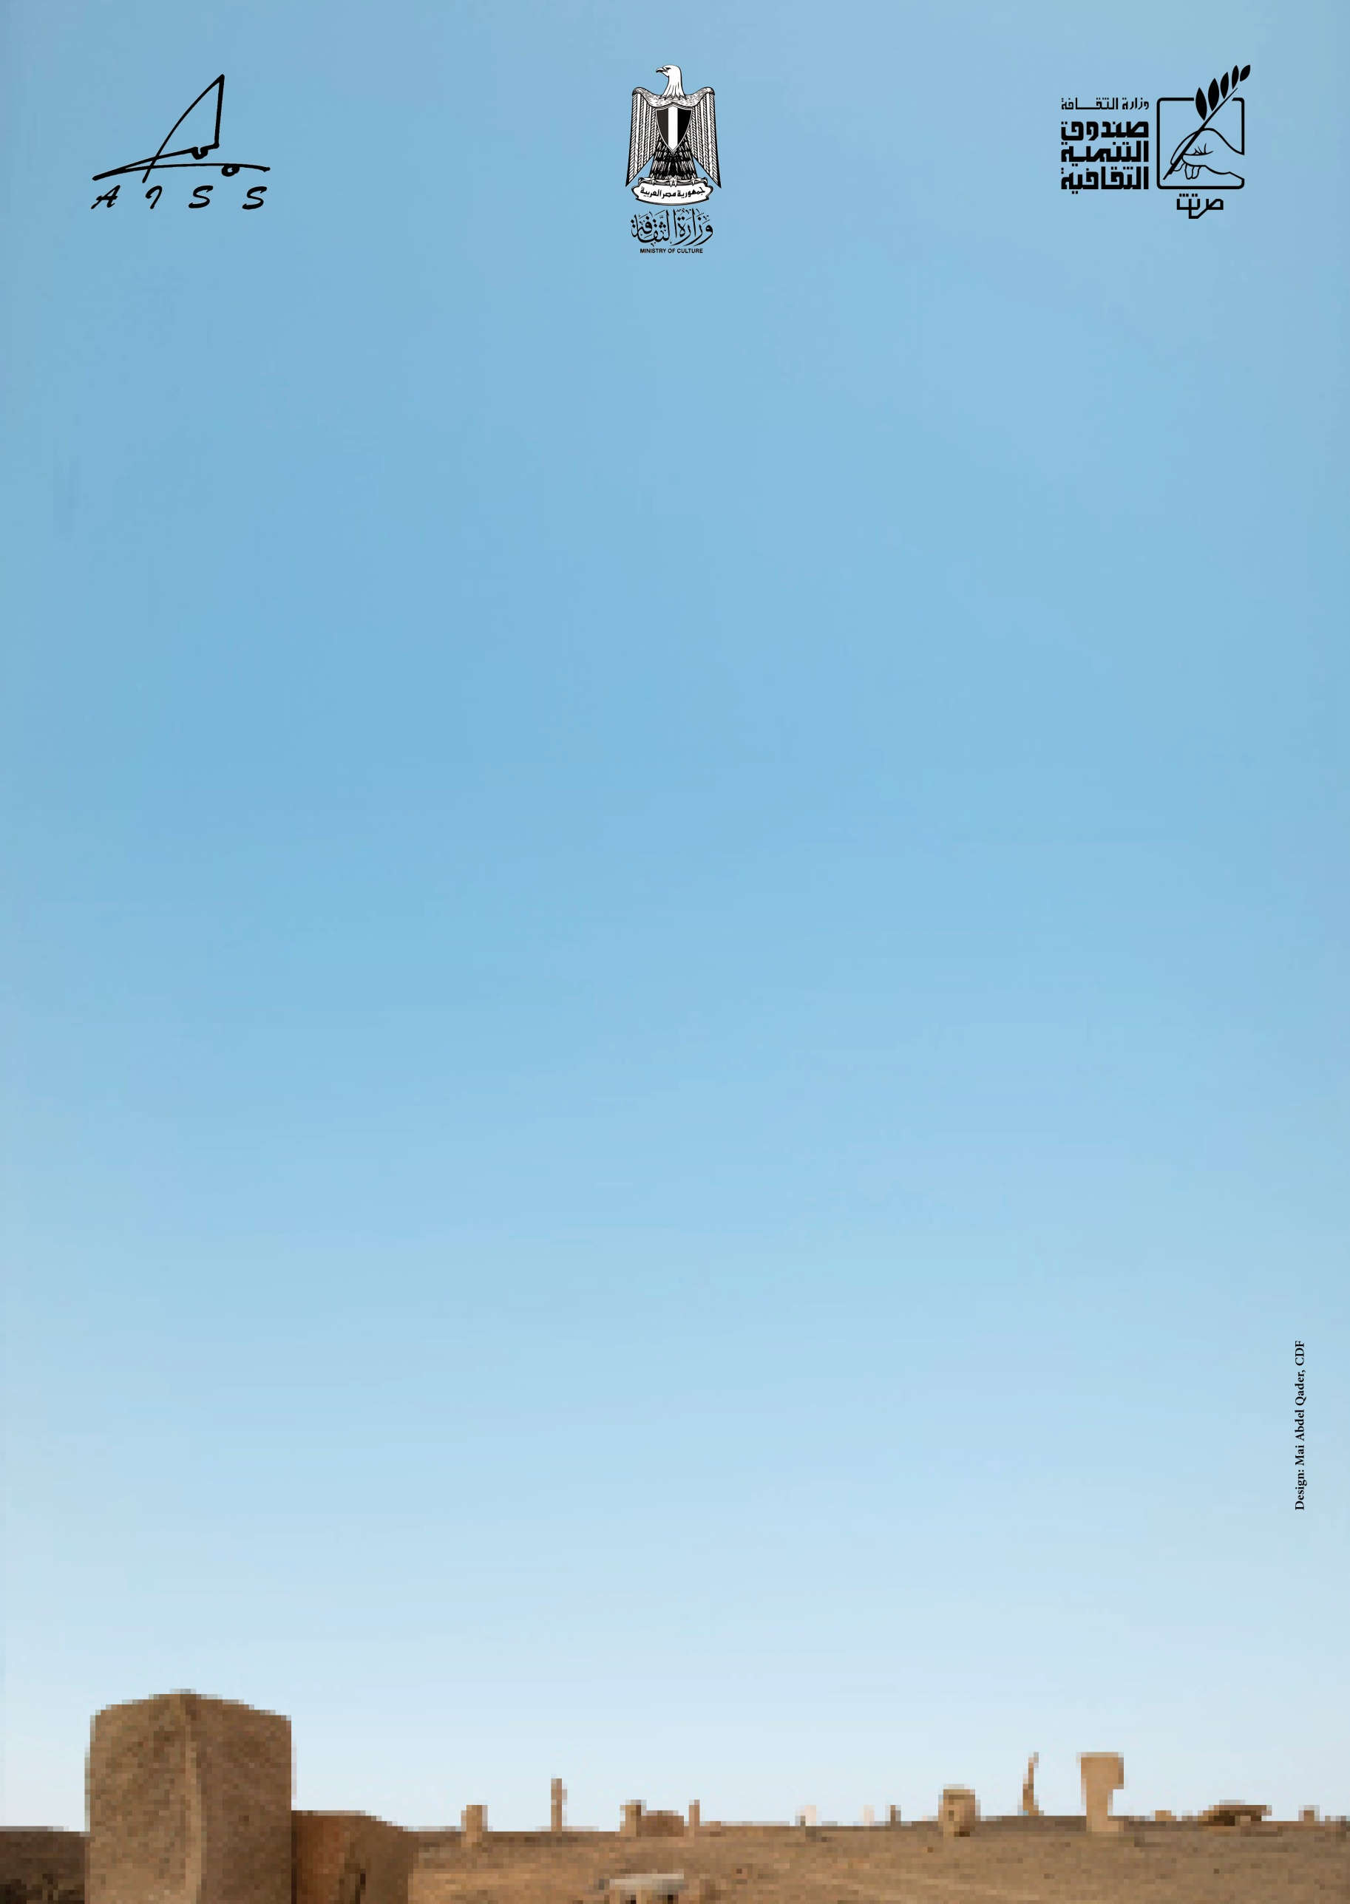

- The Symposium has the right to exhibit the works in public areas all over Egypt or in the Aswan International Open Air Sculpture Museum.
-All the necessary documents should be sent in digital form to the Symposium organizing committee e-mail: aiss@cdf.gov.eg not later than the November 15th 2018.

For the application to the Symposium, artists have to send:
- The filled and signed application form.
- Artist C.V. in English (One page)
- Photos of 3 models/sketches of suggesting sculptures (3 points of view)
- Photos of 5 previous sculptures in the same material.
- The description of the project (Titles, Dimensions)
- Passport photocopy.
- Recent personal photo.
- The results of the selections will be published at the website of the symposium on the http://www.aiss.gov.eg/
- Signing the application form means acceptance of all the conditions mentioned above.

General Commissioner
Of the Symposium

Hany faisal
FAX: 00 202 27364634
Tel.: 00 202 27380947
Web Site: http://www.aiss.gov.eg/
E-mail: : aiss@cdf.gov.eg
Administrative building – Opera House Area, El Gezira, Cairo, Egypt.
P.O. Box: 119 Mohamed Farid, Cairo, Egypt.

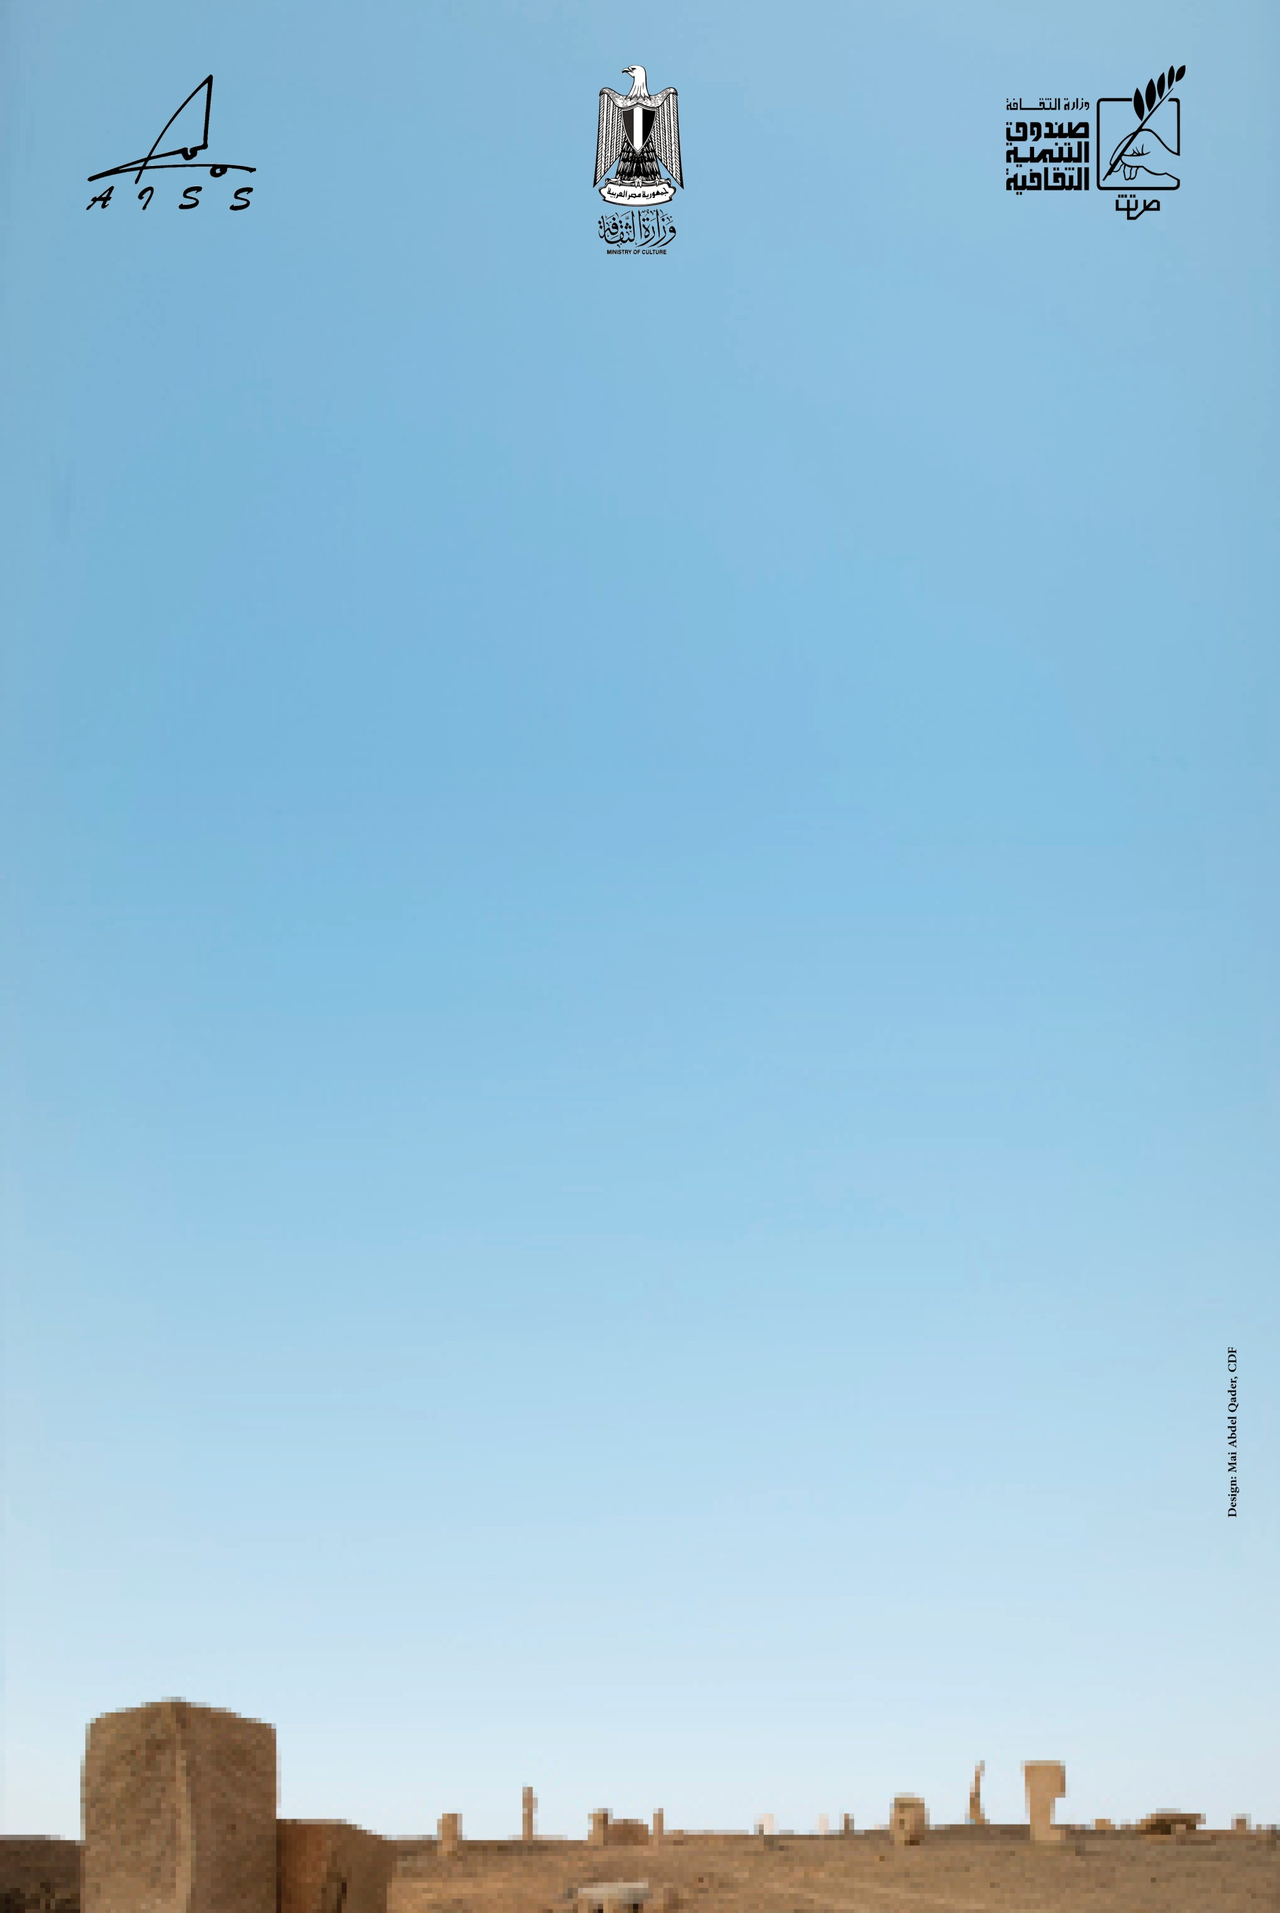

Application
Photo

Family Name : …….. First Name: ……..
Date of Birth:……… Place of Birth: ……..
Present Nationality: ……..
Original Nationality: ………
Present Address : …………….
City : ……… Country : ………….
Tel: ………… Fax : ……….
E- mail: ……………….
Permanent Address: …………….
Passport No.: ……….. Issued From: …………..
Date of Issue …… Valid until : ………..
Additional Information: …………………………………………………………………………………………………………………………………
…………………………………………………………………………………………………………………………………
Name: ………………………..
I accept all the conditions mentioned in the regulation.
Date: …………………….
Signature: ……………….

FAX: 00 202 27364634
Tel.: 00 202 27380947
Web Site: http://www.aiss.gov.eg/ E-mail: aiss@cdf.gov.eg
Administrative Office – Opera House Area, El Gezira, Cairo, Egypt.
P.O. Box : 119 Mohamed Farid, Cairo, Egypt.

